Mc Grath, John (from Linked In)
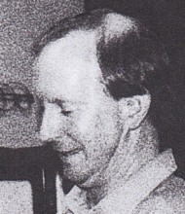

Research Director at Future Farm Industries Cooperative Research Centre.
Educated at | the University of Western Australia.

Research Director Future Farm Industries Cooperative Research Centre.

Member Institute of Foresters of Australia 1990 – Present (23 years).

Research Director Future Farm Industries CRC 2010 – 2011 (1 year).

Manager Forest Science and Resources Forest Products Commission, Western Australia 2003 – 2011 (8 years).

Board Member CRC Greenhouse Accounting 2003 – 2006 (3 years).

